

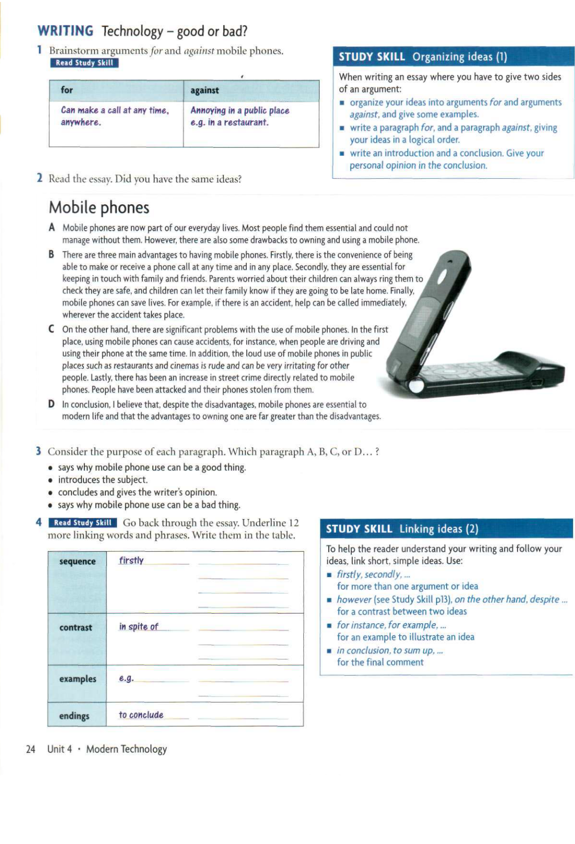
THE BEST STRUCTURE YOU CAN USE FOR THIS TYPE OF ESSAY IS:
Paragraph 1- Introduction
Sentence 1- Paraphrase Question
Sentence 2- Thesis Statement
Sentence 3- Outline Statement
Paragraph 2- Supporting Paragraph 1
Sentence 1- Topic Sentence
Sentence 2/3- Explain Topic Sentence
Sentence 3/4- Example
Paragraph 3- Supporting Paragraph 2
Sentence 1- Topic Sentence
Sentence 2/3- Explain Topic Sentence
Sentence 3/4- Example
Paragraph 4- Conclusion
Sentence 1- Summary and reiteration of your opinion.

Some people think that universities should provide graduates with the knowledge and skills needed in the workplace. Others think that the true function of a university should be to give access to knowledge for its own sake, regardless of whether the course is useful to an employer.

What, in your opinion, should be the main function of a university?

